|  |  |  |  |  |  |  |
| --- | --- | --- | --- | --- | --- | --- |
| **PARIPEX - INDIAN JOURNAL OF RESEARCH** | | | **Volume-7 | Issue-6 | June-2018 | ISSN - 2250-1991 | IF : 6.761 | IC Value : 86.18** | | |  |
|  |  | **ORIGINAL RESEARCH PAPER** | | **Engineering** | |  |
|  |  |  |  |  |  |  |
|  |  | **SMART SURVEILLANCE MONITORING SYSTEM** | | **KEY WORDS:** Usb Cameras, Pir | |  |
|  |  | Sensor, Raspberry Pi, Relay, 3g | |  |
|  |  | **USING RASPBERRY PI AND PIR SENSOR** | |  |
|  |  | Dongle, Smart Phone | |  |
|  |  |  |  |  |
|  |  |  | | |  |  |
|  | **Maya Nayak** | Principal, Orissa Engineering College, Bhubaneswar, Odisha, INDIA | | | |  |
|  |  |  |  |  |  |  |

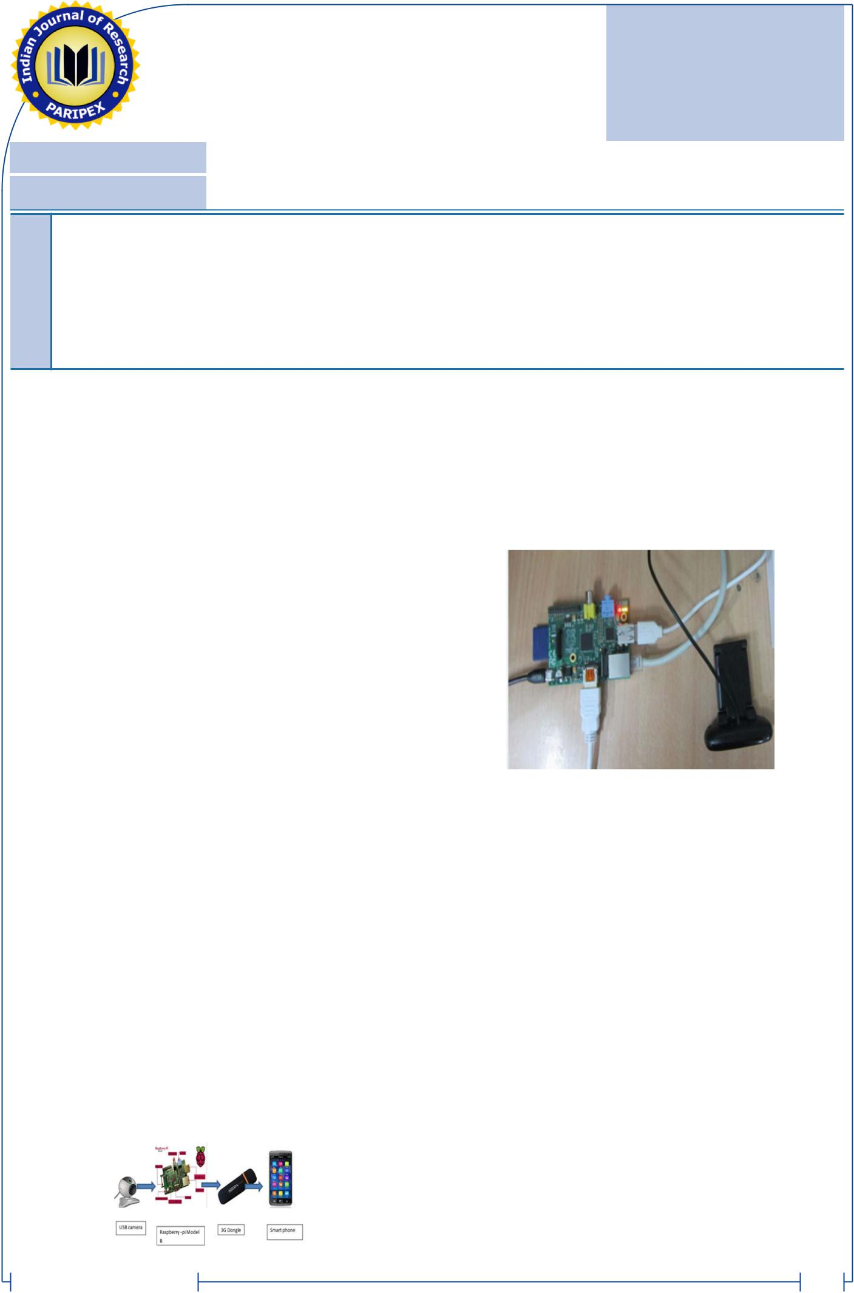

**Prasannajit Dash** Senior Software Engineer, OAASA Technologys, Kolkata, West Bengal, INDIA

|  |
| --- |
| **ABSTRACT** |

This paper deals with the design and implementation of Smart surveillance monitoring system using Raspberry pi and PIR sensor for mobile devices. It increases the usage of mobile technology to provide essential security to our homes and for other control applications . The proposed home security system captures information and transmits it via a 3G Dongle to a Smart phone using web application. Raspberry pi operates and controls motion detectors and video cameras for remote sensing and surveillance, streams live video and records it for future playback. It can also find the number of persons located with the help of the Infrared sensor. For example , when motion is detected, The cameras automatically initiate recording and the Raspberry pi device alerts the owner of the possible intrusion having a smart phone. Raspberry - Pi has two main components interacting with each other: one is the Web Application that executes on the mobile device's browser and server -side scripts that run in a cloud which will be operated by the Raspberry Pi Hardware tool component

**INTRODUCTION**

Raspberry pi is a credit- card sized computer .It functions almost as a computer. There are various surveillance systems such as camera, CCTV etc., In these types of surveillance systems, the person who is stationary and is located in that particular area can only view what is happening in that place .Whereas, here, even if the user is moving from one place to another ,he/she can keep track of what is happening in that particular place. Also another advantage is that it offers privacy on both sides since it is being viewed by only one person .The other major advantage is that it is a simple circuit

.the operating system used here is Raspbian OS.Raspbian OS has to be installed so that the image can be transmitted to the smartphone

**I. FUNCTIONAL DESCRIPTION**

The functions of the various components are given below:

***A. USB Camera:***

USB Camera captures the image and sends it to the USB port of the Raspberry Pi board. The camera model used here is USB Camera model 2.0.

***B. Raspberry Pi:***

Raspberry pi is a small credit-card sized computer capable of performing various functionalities such as in surveillance systems, military applications, etc. The various

functionalities of the components are given below The various components of Raspberry- Pi are

* *SD Card Slot* is used to install OS/booting/long term storage

.The total memory of the SD card is about 16GB.

* *Micro USB Power Port* provides 700mA at 5A.
* *RCA Video Out* is connected to display if HDMI output is notused. It is mainly used to carry audio and video signals. They are otherwise called as A/V jacks.
* *Audio Out* Digital audio is obtained if HDMI is used to obtainstereo audio. Here analogue RCA connection is used.
* *Ethernet Port* is used to connect to the Internet. It also
* plays a role in updating, getting new software easier.
* *HDMI OUT(High Definition Multimedia Interface)* is used withHDTVs and monitors with HDMI input. Also HDMI-HDMI is used here.
* *BROADCOM BCM* 2835: It is otherwise defined as System onchip .It is a 700 MHz Processor. It has a Video core IV GPU.
* *GPIO* allows us to control and interact with real world.

***Fig 1: System Design***

www.worldwidejournals.com

**II.HARDWARE ARCHITECTURE**

In the figure 1,Raspberry Pi is connected to the USB camera with the help of USB port .In the PC ,Raspbian operating system is installed. Raspberry-pi works only on Raspbian operating system ,Linux., Raspbian is a free operating system based on Debian optimized for the Raspberry Pi hardware. An operating system is the set of basic programs and utilities that make your Raspberry Pi run. However, Raspbian provides more than a pure OS: it comes with over 35,000 packages, pre-compiled software bundled in a nice format for easy installation on your Raspberry Pi.

***Fig 2: Connection Of USB Camera With Raspberry Pi***

Putty configuration and VNC viewer are needed to install Raspbian OS . Putty configuration is SSH and Telnet client .It is a open source software that is available with source code. Virtual network computing is a Graphical desktop sharing system that allows us to remotely control the desktop interface of one computer from another.

The Raspberry Pi primarily uses Linux kernel-based operating systems (it is not possible to run Windows on the Raspberry Pi). The ARM11 is based on version 6 of the ARM on which several popular versions of Linux no longer run (in current releases), including Ubuntu. The install manager for Raspberry Pi is NOOBS. The OSs included with NOOBS are:

Arch linux ARM

Open ELEC

Pidora (Fedora Remix)

Raspbmc and the XBMC open source digital media center

RISC OS  The operating system of the first ARM-based computer Raspbian (recommended)  Maintained independently of the Foundation; based on the ARM hard-float(armhf) Debian 7 'Wheezy' architecture port originally designed for ARMv7 and later processors (with Jazelle RCT/ThumbEE, VFPv3, and NEON SIMD extensions), compiled for the more limited ARMv6 instruction set of the Raspberry Pi. A minimum size of 2 GB SD card is required, but a 4 GB SD card or above is recommended. There is a Pi Store for exchanging programs.

493

**PARIPEX - INDIAN JOURNAL OF RESEARCH** **Volume-7 | Issue-6 | June-2018 | ISSN - 2250-1991 | IF : 6.761 | IC Value : 86.18**

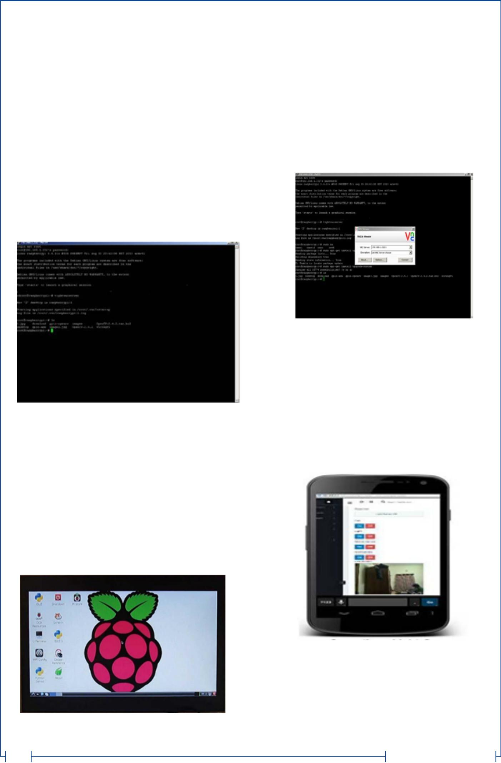

* The Raspbian Server Edition is a stripped version with other software packages bundled as compared to the usual desktop computer oriented Raspbian.
* The Wayland display server protocol enable the efficient use of the GPU for hardware accelerated GUI drawing functions Raspbian for Robots - A fork of Raspbian for robotics projects with LEGO, Grove, and Arduino

1. i .**STEPS FOR THE PuTTY CONFIGURATION**
2. Obtain a copy of PuTTY pre-configured for use at Columbia from the PuTTY download page.
3. Save the installer file to your download directory or desktop.

**Important: Exit all applications before you begin the installation process.**

1. Double-click on the file PuTTY-install.exe to begin the installation.
2. At the **Choose Destination** screen, Click **Next** to accept the recommended default destination location for installing PuTTY.
3. Click **Next on the Select Program Folder** screen to select PuTTY as the recommended Program Folder name (**PuTTY** should already be displayed in the Program Folders text box).
4. Click Finish on the final screen to complete the installation.

Once you have an operating system running here are the required steps to install a VNC server:

1.Open LX terminal

1. In LX terminal type in "sudo apt-get update" to update the operating system to the latest version
2. When prompted to update type in "y" and press enter.
3. After updating is complete type in "sudo install tightvncserver". Press "y" and hit enter when prompted
4. Once tight VNC server has completed installation you can start it by typing in "vncserver:1"
5. It will prompt you to create a password. Keep in mind passwords can be at MOST 8 characters long.
6. Enter a password .The VNC server is now running in the background of your Raspberry Pi's operating system. We use any computer on your network with a VNC client to remotely access the Raspberry Pi

***Fig 3:PuTTY configuration***

1. **STEPS TO INSTALL RASPBIAN OS**

In order to install Raspbian OS,first next out of box

software(NOOBS) has to be installed.

1. First step is to allocate the drive for installing OS
2. SD adaptor can also be used for this purpose
3. Download WINDISK 32 utility from source forge project which is a zip file
4. Extract and run the zip file
5. Select the file and click run as administrator 6.Select the image

file which was extracted above

1. Select the drive letter of the SD card in the device box
2. Click write and wait for write process to complete
3. Exit the image and eject the SD card

***Fig 5:VNC Viewer***

IV. **RESULTS AND DISCUSSION**

Raspberry Pi has enough power for HD video and image manipulation, and can be connected to the Arduino board. Connected to Raspberry Pi, Arduino can be used as a control unit while Raspberry Pi processes video images. Raspberry Pi features include Bluetooth and Wi-Fi wireless technologies and this is the shortcut to display images directly on the Android device.

Video images are displayed at high FPS and are in colors

**Transmission Of Video /Image Via A 3G Dongle To A Smartphone**

***Fig 4:Installed Raspbian OS***

1. **INSTALLATION OF VNC VIEWER**

494

***Fig6.Final Image Video***

V.**CONCLUSION AND FUTURE WORK**

Thus we have designed a smart surveillance system capable of recording/capturing video/image and transmitting to a smart phone. It is advantageous as it offers reliability and privacy on both sides. It is authenticated and encrypted on the reciever side,hence it offers only the person concerned to view the details .Neccesary action can be taken in short span of time in the case of emergency conditions such as elderly person falling sick,military areas, smart

www.worldwidejournals.com

**PARIPEX - INDIAN JOURNAL OF RESEARCH** **Volume-7 | Issue-6 | June-2018 | ISSN - 2250-1991 | IF : 6.761 | IC Value : 86.18**



homes, offices, industries etc., Future work is to locate the number

of persons located exactly on that area and their position so that

accurate information can be obtained on the receiver side.

**References**

1. Sharma, Rupam Kumar, et al. "Android interface based GSM home security system." Issues and Challenges in Intelligent Computing Techniques (ICICT), 2014NInternational Conference on. IEEE, 2014.
2. De Luca, Gabriele, et al. "The use of NFC and Android technologies to enable a
3. Gu, Yi, et al. "Design and Implementation of UPnP-Based Surveillance Camera System for Home Security." Information Science and Applications (ICISA), 2013 International Conference on. IEEE, 2013.
4. Van Thanh Trung, Bui, and Nguyen Van Cuong. "Monitoring and controlling devices system by GPRS on FPGA platform." Advanced Technologies for Communications (ATC), 2013 International Conference on. IEEE, 2013.
5. Karia, Deepak, et al. "Performance analysis of ZigBee based Load Control and power monitoring system." Advances in Computing, Communications and Informatics (ICACCI), 2013 International Conference on. IEEE, 2013.
6. Ryu, Yeonghyeon, Jeakyu Yoo, and Youngroc Kim. "Cloud services based Mobile monitoring for Photovoltaic Systems." Cloud Computing Technology and Science (CloudCom), 2012 IEEE 4th International Conference on. IEEE, 2012.
7. Robson, Clyde, et al. "High performance web applications for secure system monitoring and control." Nuclear Science Symposium and Medical Imaging Conference (NSS/MIC), 2012 IEEE. IEEE, 2012.
8. Han, Jinsoo, et al. "User-friendly home automation based on 3D virtual world." Consumer Electronics, IEEE Transactions on 56.3 (2010): 1843-1847.
9. Bajorek, Marcin, and Jedrzej Nowak. "The role of a mobile device in a home monitoring healthcare system." Computer Science and Information Systems (FedCSIS), 2011 Federated Conference on. IEEE, 2011.
10. Acker, Robin, and Michael Massoth. "Secure ubiquitous house and facility control solution." Internet and Web Applications and Services (ICIW), 2010 Fifth International Conference on. IEEE, 2010.
11. Tupakula, Udaya, Vijay Varadharajan, and Sunil Kumar Vuppala. "Security Techniques for Beyond 3G Wireless Mobile Networks." Embedded and Ubiquitous Computing (EUC), 2011 IFIP 9th International Conference on. IEEE, 2011.
12. Kosba, Ahmed E., and Moustafa Youssef."RASID demo: A robust WLAN device-free passive motion detection system." Pervasive Computing and Communications Workshops (PERCOM Workshops), 2012 IEEE International Conference on. IEEE, 2012.

|  |  |
| --- | --- |
| www.worldwidejournals.com | 495 |